SUSTAINABLE DEVELOPMENT GOALS.

**Part 1: SDG Selection and Problem Definition**

**SDG Selection:**

* **SDG 6:** Clean Water and Sanitation

**Problem Definition:**

* **Access to Safe Drinking Water:** Many communities around the world, especially in rural and underdeveloped regions, lack access to safe and clean drinking water. Contaminated water sources can lead to waterborne diseases, posing significant health risks. The challenge lies in identifying areas with inadequate access to safe water and prioritizing interventions to improve water quality and availability.

This problem can be addressed using data on water quality, availability, infrastructure, and health outcomes to identify the most affected areas and track the effectiveness of interventions over time.

PART 2

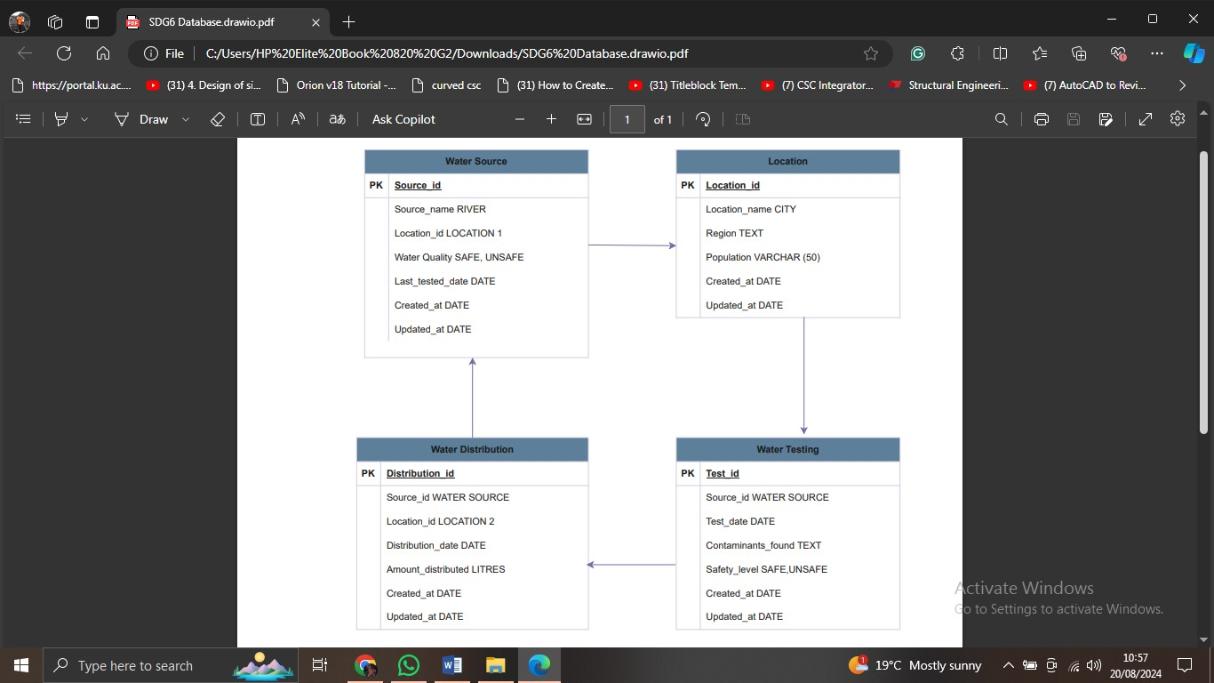

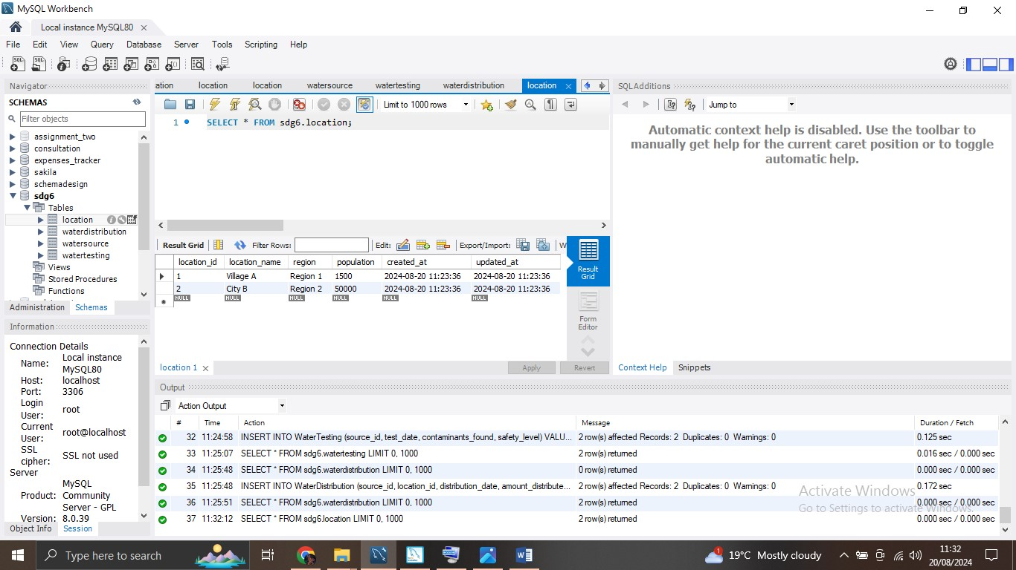

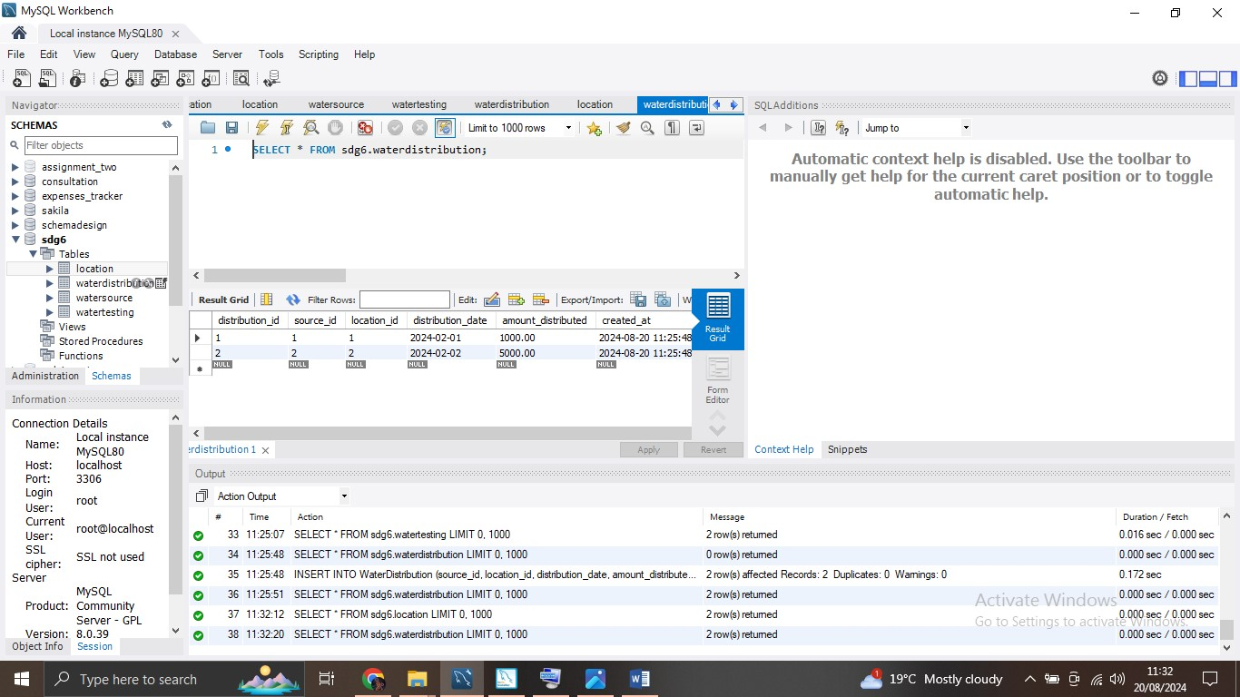

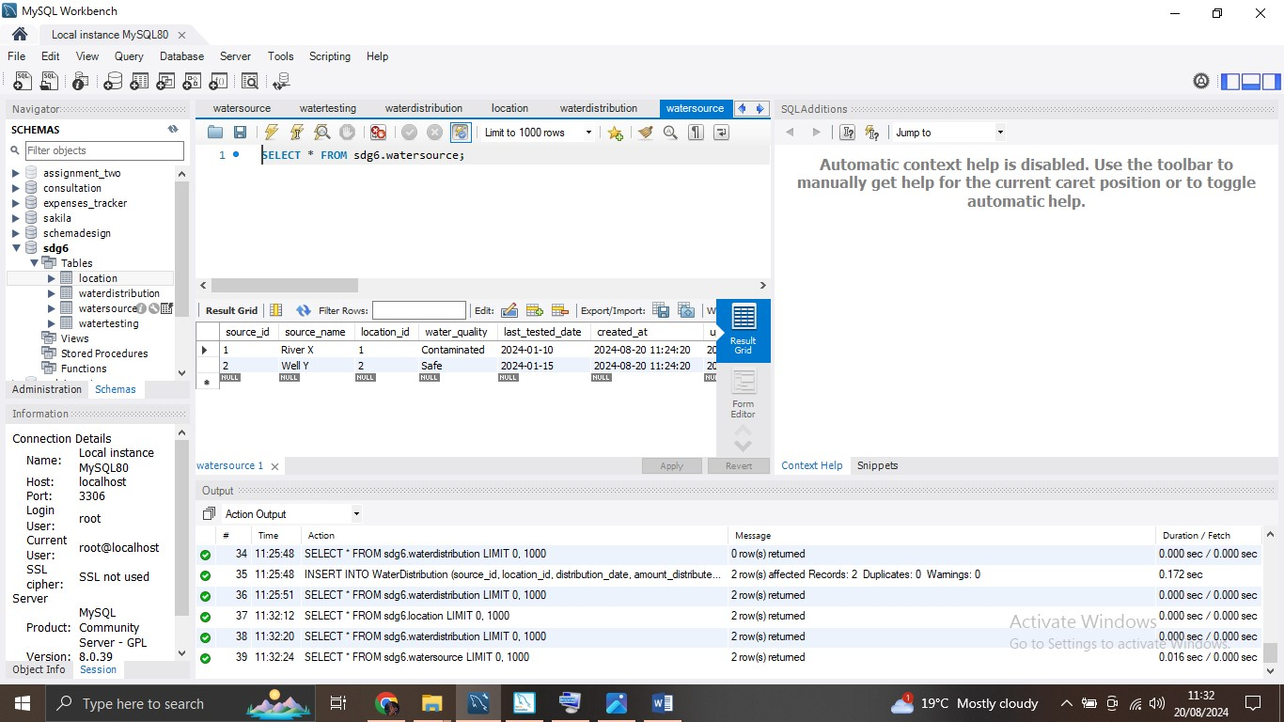

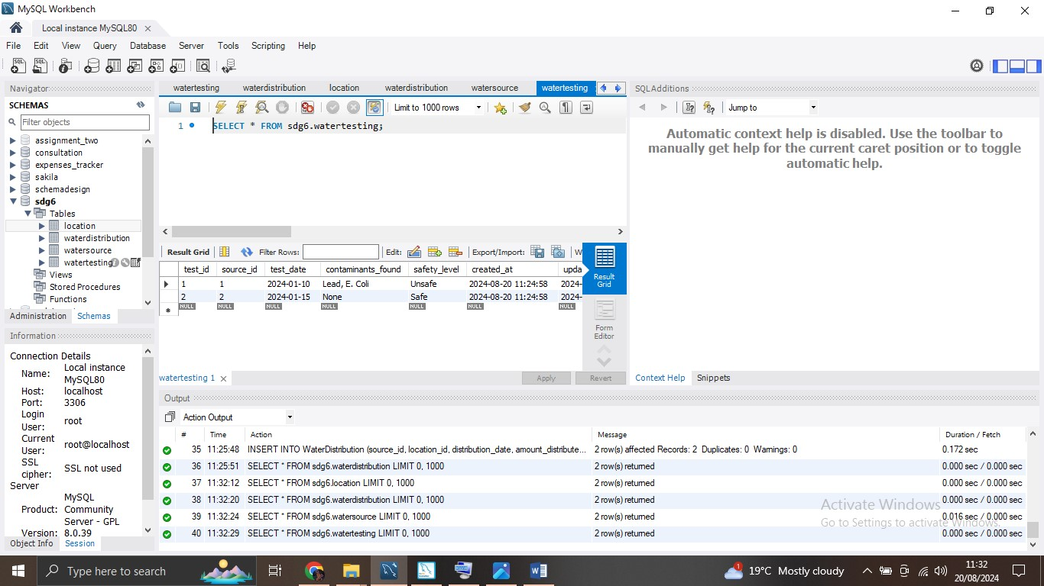

PART 3: DATA RETRIEVAL.

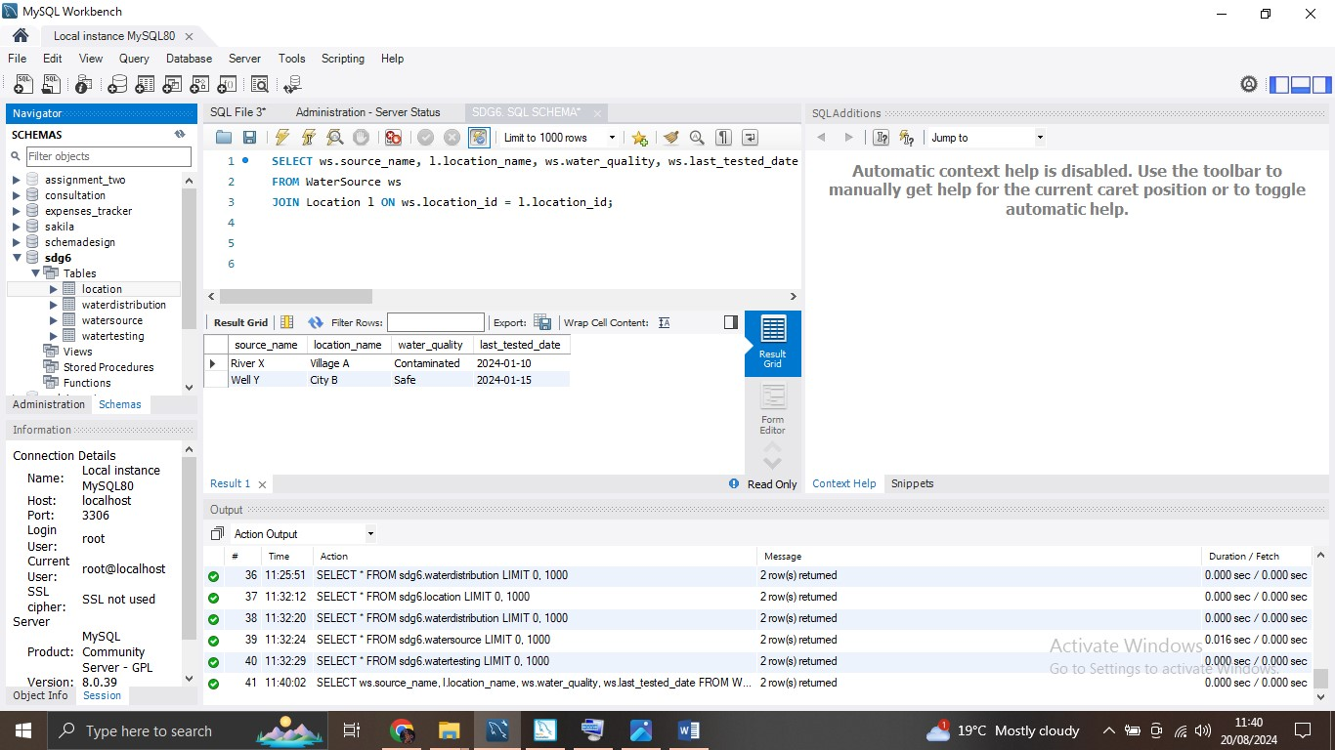

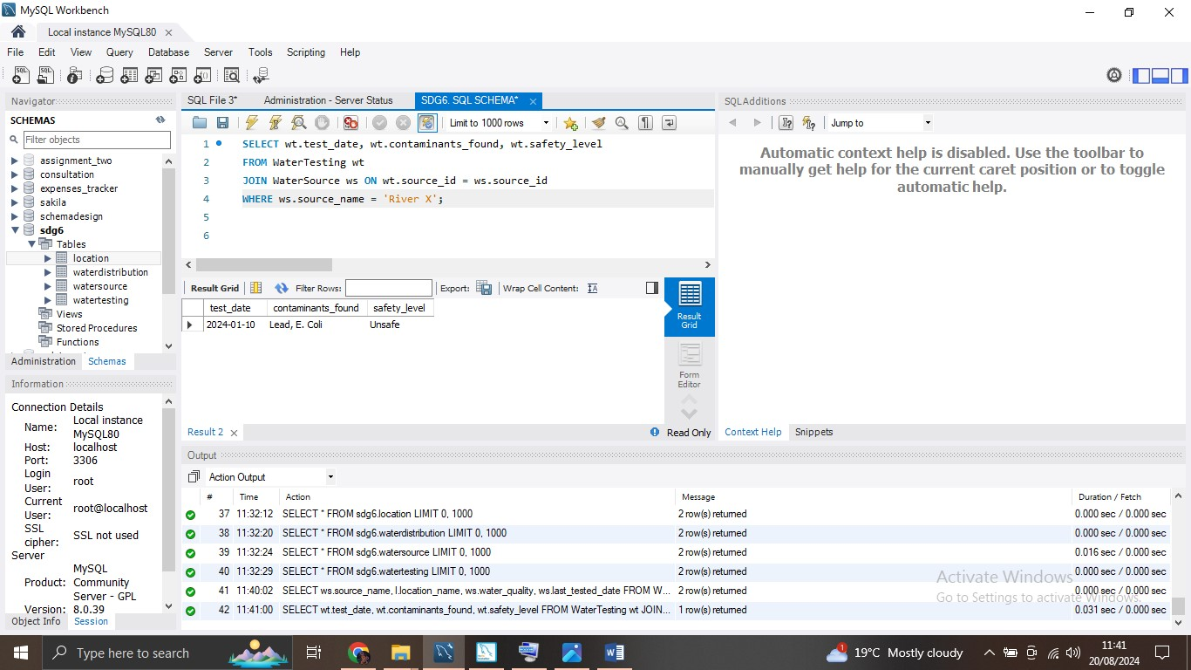

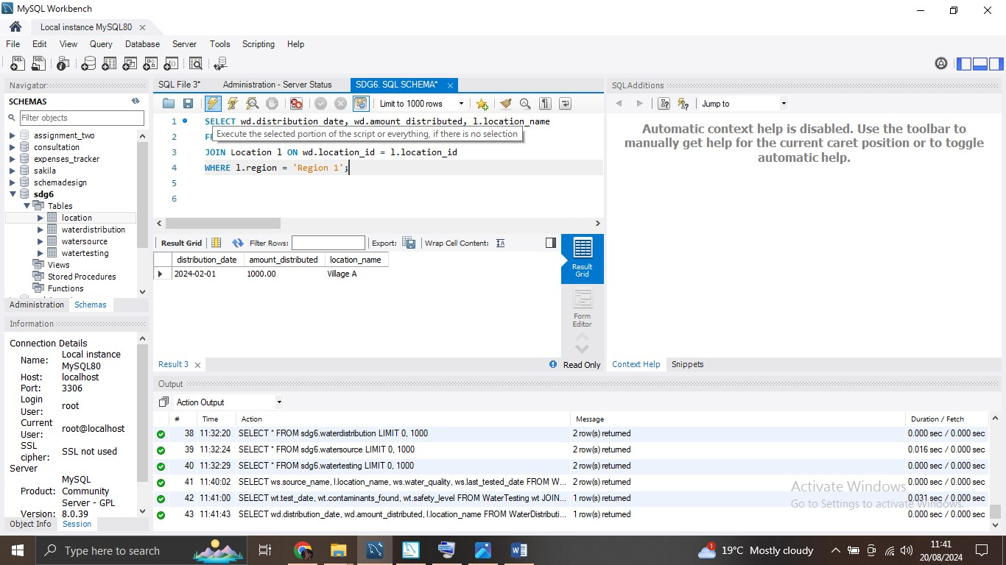

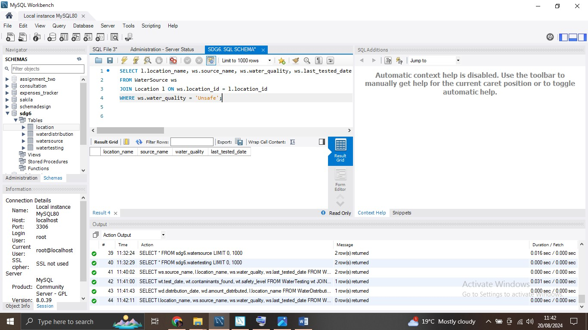DATA ANALYSIS.

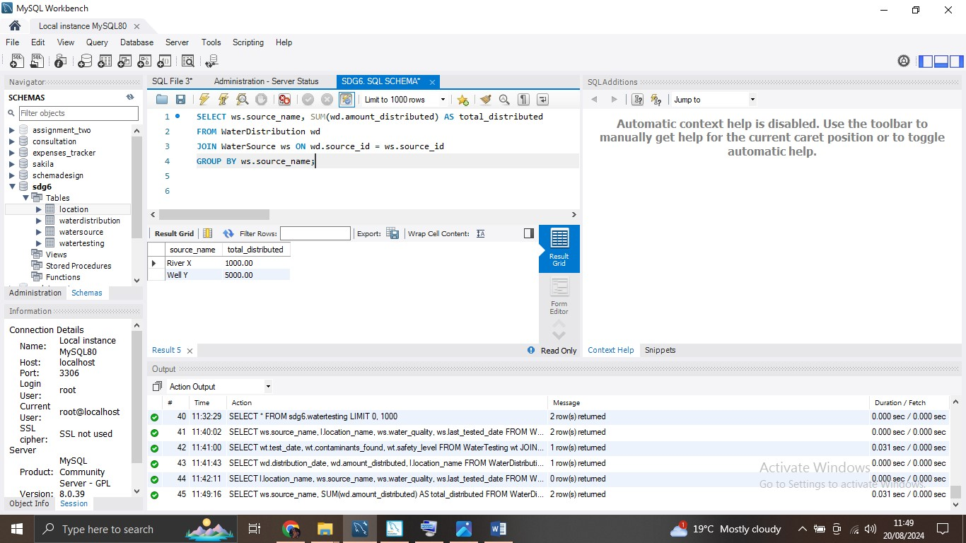

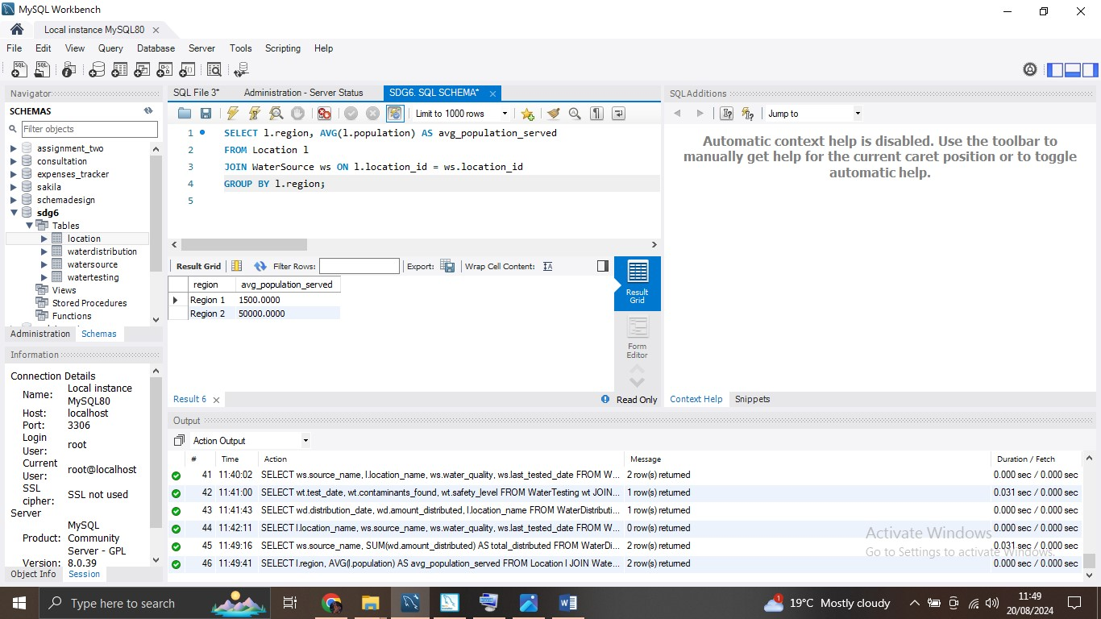

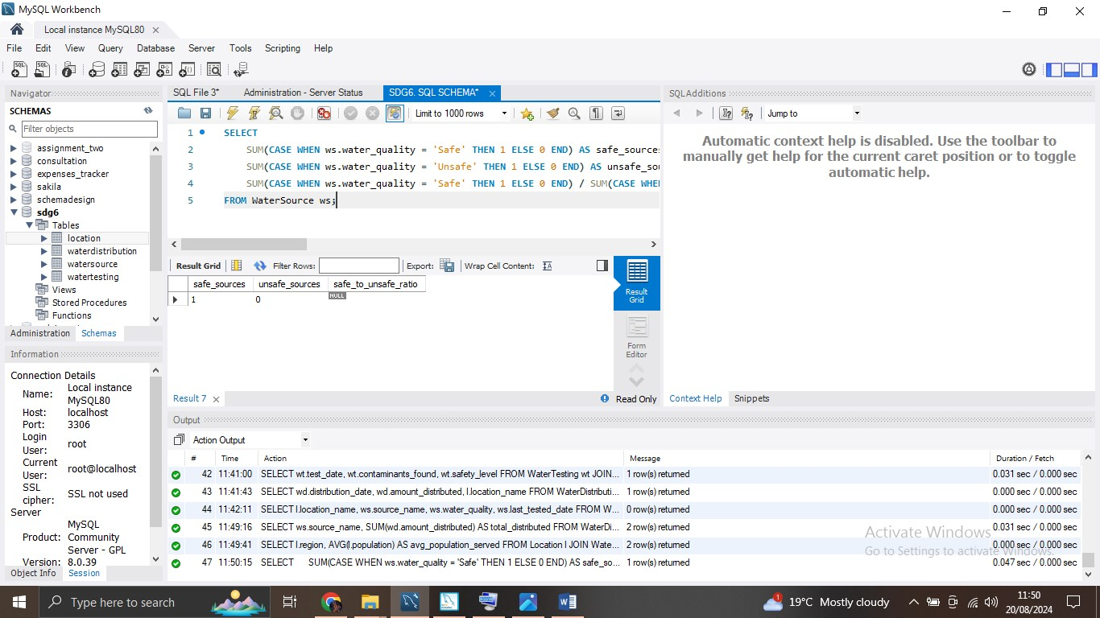

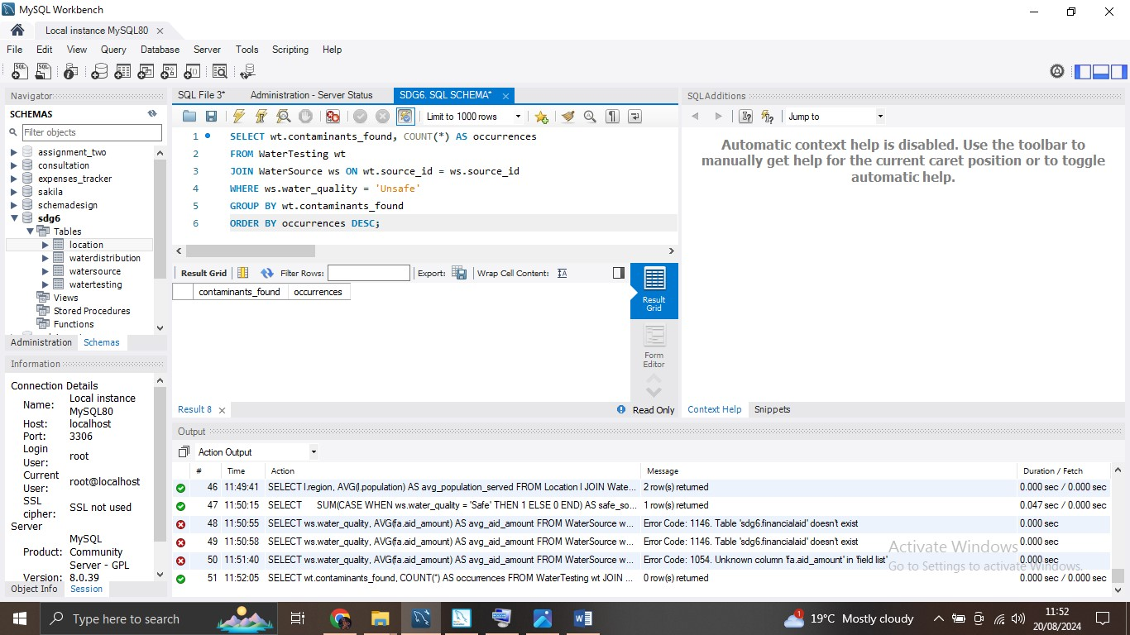

PART 4 – DATA ANALYSIS USING EXCEL.

PITCHDECK LINK - https://www.canva.com/design/DAGOwuyU5W8/p46nPhJX_wahgT1MUKDsiw/edit?utm_content=DAGOwuyU5W8&utm_campaign=designshare&utm_medium=link2&utm_source=sharebutton